Lab 8: Working in the Linux Command Line

Answer Sheet – point values follow each item

Note: Student can use various forms of the commands as long as the action completed is what is required. Clear command will not be shown as the screen will have been cleared. Grade based on previous material not being displayed on the screen.

# Student Submission - Your Task

Complete the below actions using the skills you learned above. Where noted provide a screenshot of your terminal on the lab answer sheet for submission.

1. Clear your terminal screen (2 pts)
2. Display your present working directory (2 pts)
3. Search the /etc directory and display all the occurrences of ‘student’ sending the output to a file named student.txt (2 pts)
4. Provide the long format listing of all the files (not including hidden) of the present directory (2 pts)
5. Display the contents of the student.txt file (2 pts)

Provide a screenshot of your terminal screen

1. Clear your terminal screen (2 pts)
2. Make a directory named ‘homework’ (2 pts)
3. Copy the system_info.sh script you created earlier into the new homework directory (2 pts)
4. Change your present directory to the newly created homework directory (2 pts)
5. Display a history of the commands you have entered (2 pts)

Provide a screenshot of your terminal screen

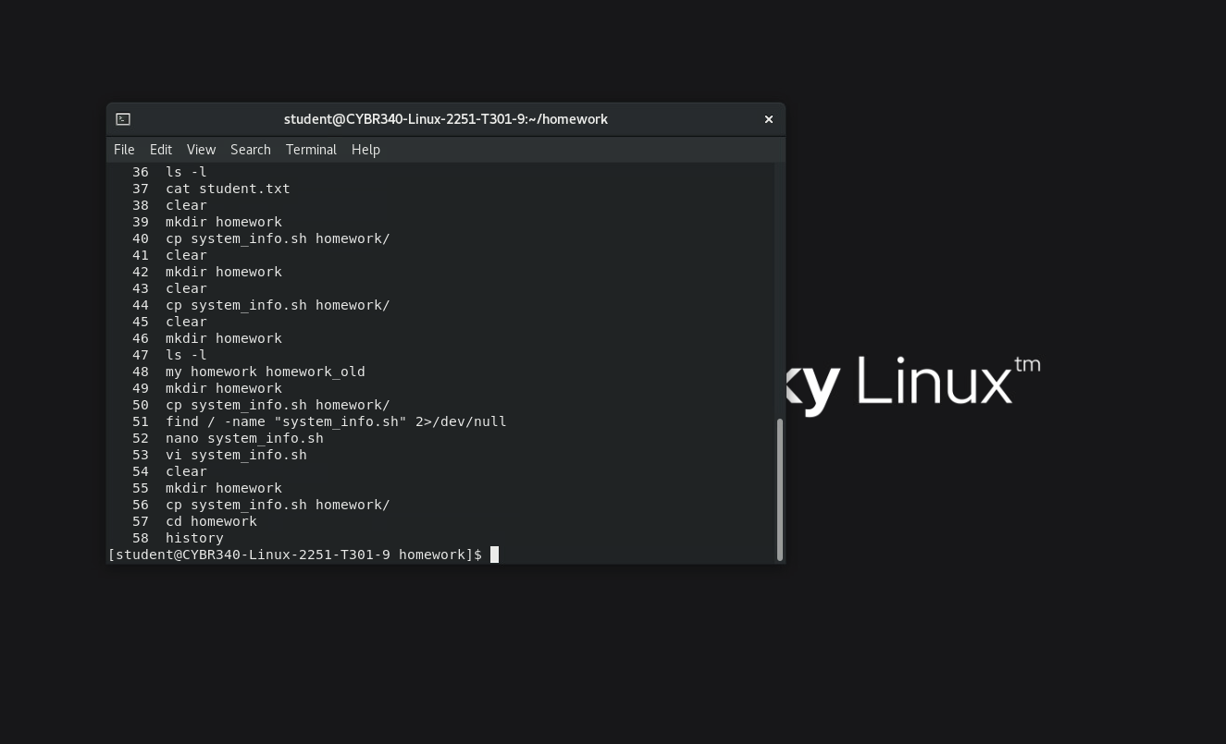

1. Clear your terminal screen (2 pts)
2. List the running processes (2 pts)
3. Provide a short listing of the files (including hidden) in the present directory (2 pts)
4. Change the level of your rights in the terminal to root (2 pts)
5. Revert back to normal user level of rights in the terminal (2 pts)

Provide a screenshot of your terminal screen

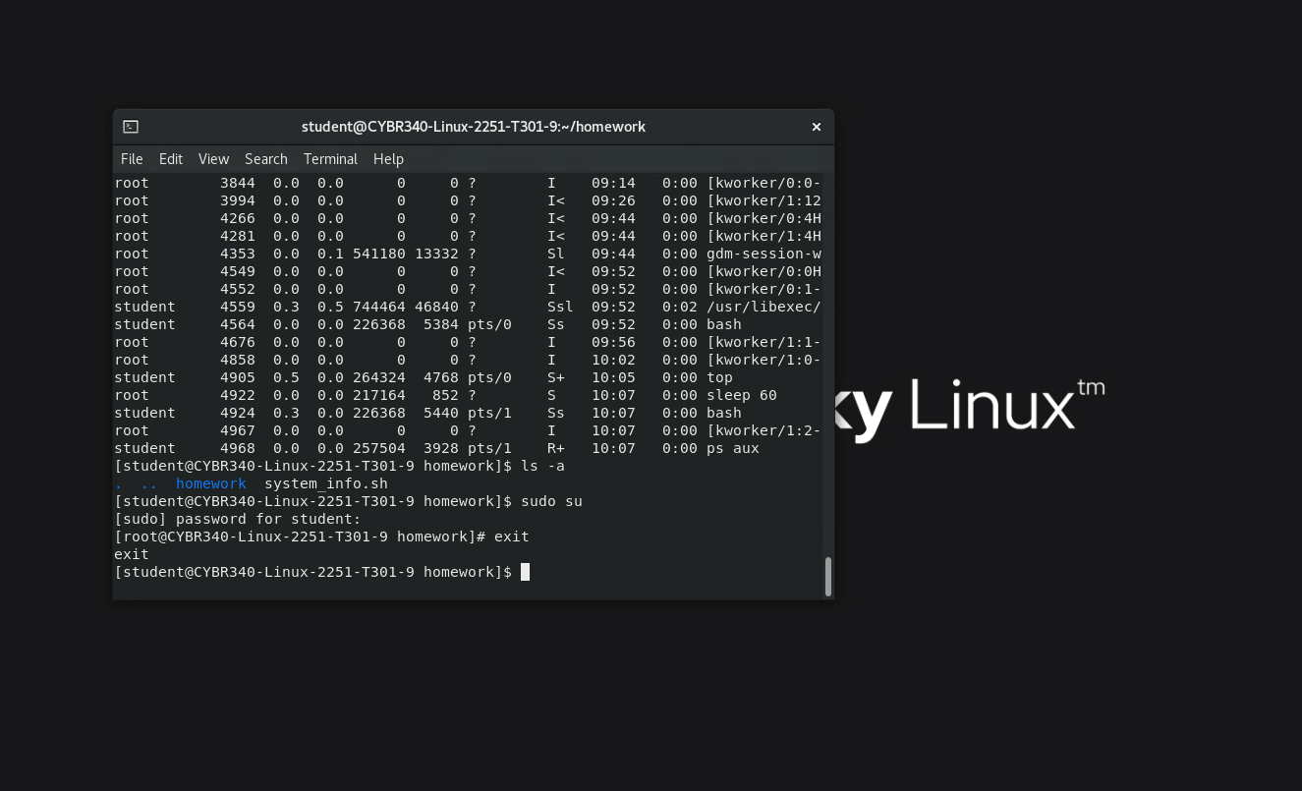

1. Clear the screen
2. Change the permissions on the system_info.sh file to make it readable only to the user (proof of this action will be shown in step #22) (2 pts)
3. Edit the system_info.sh file
4. Add lines to the script to (leave all current lines in place):
   1. Have the first lines displayed by the script be (on separate lines):
      1. Your name
      2. CYBR340
      3. ------------------
      4. System Info
   2. Add to the end of the script
      1. The text “Memory Usage:” followed by the output of the command ‘free -h’
      2. The text “Logged-in users:” followed by the output of the who command

Provide a screenshot of the editor screen displaying your code

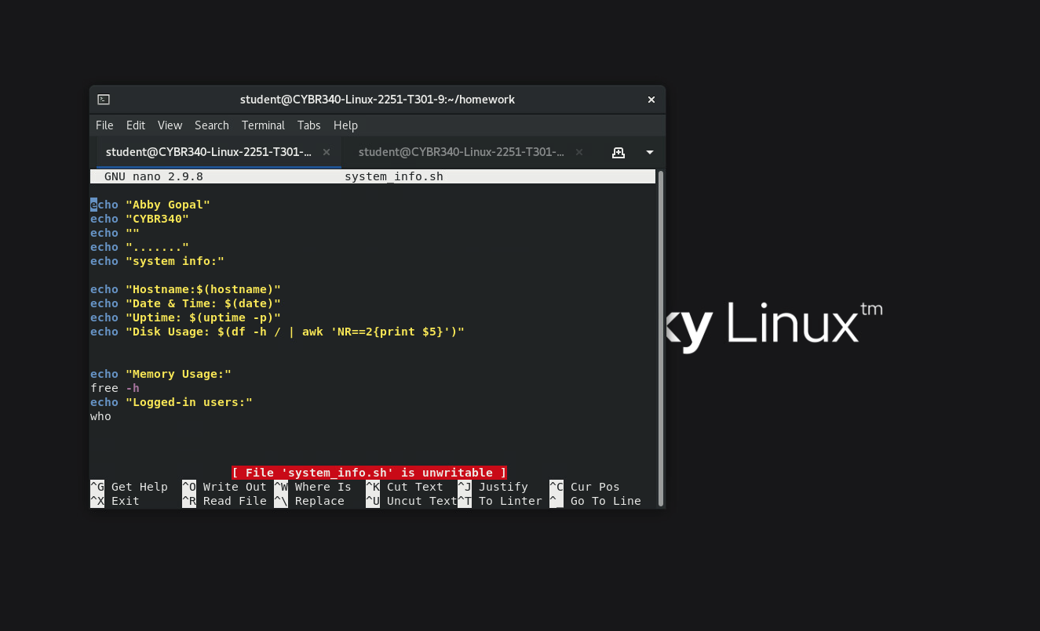

1. Save the file and exit the editor
2. Make a copy of your script and name it ’backup’ (2 pts)
3. Display a long listing of the present directory (2 pts)
4. Run your script (10 pts for correct output of script)
5. Delete the file you created named backup (2 pts)
6. Display a long listing of the present directory (2 pts)

Provide a screenshot of your terminal screen



